

**The people of Suffolk County must know this before increasing taxes to construct sewers**

A debate is on the table to increase the Suffolk County sales tax by an eighth of a cent for the purported function of constructing more sewers in Suffolk.

The county also, in a rather clandestine fashion, seeks to extend the present quarter penny sales tax program out another thirty years, despite the fact that the current program doesn’t expire for another six years.

The tax increase is being sold via the scare tactic of telling Suffolk residents that if they don’t fork over billions of dollars to the government over the next three decades, they will be drinking polluted water via failing cesspools and septic systems.

The misleading narrative being floated is that constructing sewers will lead to cleaner drinking water. If that were the case, Nassau County, which has been almost completely sewered since the 1980s, would have better water quality than Suffolk County, which is almost 75% unsewered. But that’s not the case. Nassau is now looking to the New York City reservoirs to get clean, potable water, as highlighted in the USGS/NYSDEC reports that salt water intrusion and overall aquifer depletion has occurred there.

The reason for this is that ocean outfall sewering does not return water to the ground. Instead, the water gets flushed out into the ocean. This leaves a gaping hole in the aquifer where groundwater previously existed. This causes nitrogen which is normally cycled and recycled along the surface of the aquifer, to be drawn down into the aquifer as water suppliers continue to pump new water out. It also increases the odds of salt intrusion into the water supply.

So, the irony here is that sewers, which are being touted as cleansing our water supply, are actually reducing the overall volume and compromising the quality and quantityof the water within the aquifer.

That doesn’t mean that we don’t want sewers in some places in Suffolk. They are essential in some of our downtown corridors to allow for more restaurants or additional rental units for our workforce. They are needed in industrial parks such as the Hauppauge Industrial Association to allow for a massive concentration of well paying high-tech manufacturing jobs.

That’s a justifiable reason to call for the construction of sewers. But the public should not be misled that increasing taxes to construct sewers that dump groundwater into the ocean is going to save their drinking water from being polluted. An alternative way to preserve our drinking water is to create tertiary treatment plants that cleanse our water to a potable standard, and then redeposit the water back into the aquifer to maintain historic water table heights. This prevents the nitrates just below the surface from being sucked down into the aquifer. This process already exists at some sewage treatment plants throughout Suffolk, such as in Selden, where they treat 2.6 million gallons per day (gpd) to a tertiary standard and return the water to the ground. But the colossal Southwest Sewer District is permitted for 40 million gpd with all this water being sent to the Atlantic Ocean. This daily deficit is unsustainable.

The process of rainwater percolating through sand and gravel within the aquifer naturally cleanses it. This filtering process is disrupted by pumping out higher quality water and drawing down younger water faster than the aquifer can naturally cleanse it.

In February, 1978, the US Environmental Protection Agency stated:

The problem is as follows, Long Island groundwater aquifers account for 95% of the freshwater flow in streams… 100% of subsurface flow into bays. Individual wastewater disposal systems, such as cesspool and septic tanks, return used water to the groundwater system, **sewers do not.** Therefore if cesspools and septic tanks are replaced by sewers that carry waste water to a treatment plant and then to the ocean, millions of gallons a day of potential groundwater recharge will be lost to Long Island hydrological systems. (emphasis added)

The Suffolk County Subwatershed Plan acknowledges that: “Sewering has resulted in some reduction of the amounts of water being recharged directly to groundwater.”

Developers favor sewers because once constructed all they have to do is hook into the sewer system and wash their hands of the issue. In the old days, new construction would have to be coupled with the siting of recharge basins, more commonly known as sumps. Excess water that accumulates after rainfall or from road runoff would be directed into the sump and filter back into our groundwater.

The average annual rainfall on Long Island over the 20th Century was 44 inches. A 2% withdrawal of this total precipitation would be over 38 million gallons per day (GPD). But Suffolk County pumps 400 million gallons per day (gpd), which significantly exceeds the measurement of sustainable daily yield.

The term “baseflow” is defined as all the water flowing through a stream that is NOT runoff. It is interesting to compare various areas, some with sewers and some without. The streams in areas that are sewered show a substantial decrease in base flow over time. On the other hand, areas that are unsewered, such as the Carmans River show little to no change over time.

The groundwater divide is the high ground along the “spine” of Long Island that runs east to west. Areas along the divide are known as deep recharge areas because water moves vertically downward re-filling the aquifer. From there, the water moves laterally north or south including all precipitation landing north or south of the divide. The deep recharge areas account for refilling the magothy aquifer which provides 90% of Nassau’s drinking water and approximately 50% of Suffolk’s. (<https://www.nswcawater.org/water_facts/our-long-island-aquifers-the-basics/#:~:text=The%20Magothy%20aquifer%20supplies%20more,water%20used%20in%20Suffolk%20County.&text=A%20sand%20and%20gravel%20formation,80%2D100%20million%20years%20ago>.) This explains why low density zoning such as golf courses, colleges, cemeteries, mental hospitals, airports, industrial parks, etc. were planned along the divide. It also explains why NYS enacted protections in the pine barrens 40 years ago.

As noted above, one solution is to require the developers to set aside land for recharge basins or on site tertiary treatment. But that means they would have less land to develop from which they can garner a profit.

**Misleading claims of cleaner water**

Many proponents of the sales tax increase are spouting the concept that sewers lead to cleaner drinking water. They have labeled it the Clean Water Act. However, an “act” that does not address run-off abatement and wastewater recharge will not deliver on the promise of clean water.

But as noted above, if that were the case, why would Nassau County, which is almost 90% sewered, have water quality that is more threatened than that of Suffolk's, which is only 27% sewered? The reality is that in unsewered areas, 85% of supply returns to the ground. But in sewered areas, only 20% returns. This loss leads to lower volume within the aquifer resulting in salt water intrusion and reduced water quality.

If sewers had been a silver bullet solving Nassau County's water quality concerns, then why was a report issued as recently as August 20, 2022 studying the feasibility of having Nassau County tap into New York City's abundant clean water reserves. The study entitled “*NYC-Nassau County Water Supply Interconnection*” <https://www.health.ny.gov/environmental/water/drinking/docs/nyc_nassau_county_feasibility_study.pdf> notes that Nassau County is facing current water supply challenges, including salt water intrusion and other highly concentrated contaminants. More specifically, page 6 of the study notes the following:

Nassau County’s water suppliers are facing several significant challenges:

Regulated Contaminants: The aquifers used by Nassau County contain nitrates, volatile organic chemicals (VOCs) and chloride (saltwater intrusion) concentrations in excess of regulated maximum contaminant levels (MCLs). In recent years, the widespread discovery of 1,4 Dioxane and Per & Poly-fluoroalkyl Substances (PFAS), sometimes referred to as forever chemicals, requires new treatment systems to comply with New York State Department of Health’s recently enacted MCLs for these emerging contaminants.

Saltwater Intrusion: Saltwater intrusion continues to be a concern, particularly along the northern and southern coastal areas of Nassau County. Numerous wells have been taken off-line in these coastal areas to avoid excessive levels of chlorides in the drinking water. The figure to the right is from a 2020 USGS report (Ref. #27, Appendix A) and it shows the extent of chloride concentrations exceeding 5,000 mg/L.

The extent of chlorides exceeding the drinking water MCL of 250 mg/L is much greater, but wells with chlorides approaching the MCL have been taken off-line.

Safe Yield: While water demand has been relatively steady in Nassau County, the potential loss of wells due to saltwater intrusion and chemical contamination raises concern over the ability to meet future needs. The Lloyd aquifer is the deepest of the three aquifer units, and the least contaminated; however, use of the Lloyd wells has generally been reserved for areas along the north and south shores, which are most susceptible to saltwater intrusion.

Other Emerging Contaminants: As analytical detection limits improve laboratories are finding ever smaller, trace concentrations of known or suspected contaminants. Health officials are exploring the risks from trace amounts of these other emerging contaminants such as the PFAS compounds commonly referred to as GenX chemicals and PFBS. It is likely that Safe Drinking Water Act (SDWA) regulations will continue to become more stringent, requiring the water suppliers in Nassau County to remove more of these contaminants from their groundwater supplies.

**Suffolk aquifers are relatively clean**

As noted above, effluent that goes into our cesspools will eventually flow through sand and gravel in a filtering process as the water recharges into the aquifer.

There is little problem when the flow of the water is directly from the surface straight down into the deep aquifer. The situation is more complicated in areas where the flow of water travels laterally toward our coastal areas rather than vertically.

Most of our drinking water comes from the deep aquifers and remains very clean. In fact, the Suffolk County Water Authority states emphatically that of the 600 public wells that provide drinking water in Suffolk County, only two have been negatively impacted to the point of having to retire them.

<http://s1091480.instanturl.net/dwqr2024/AWQR%202024%20FINAL.pdf>

As stated above, when there is adequate water underground, the nitrates that typically exist at the surface will also move laterally along with water flowing toward our coastal areas. This water will be cycled and recycled by plants and animals along that route like a conveyor belt. Contaminants will therefore not be drawn into the aquifer. This movement is disrupted when outfall sewering is introduced along with supply.

This is why sewers can actually be more problematic for the protection of our groundwater. According to a study from the University of California Santa Barbara (<https://news.ucsb.edu/2022/020722/slurping-groundwater>):

Groundwater transports dissolved compounds called solutes. Some of these are harmful like nitrates… The surface borne contaminants are filled and broken down over the years as water percolates through the Earth. As a result, deeper wells draw up older ground water with lower concentrations of these contaminants. By pulling young groundwater deeper more quickly, we are potentially moving the surface bar pollutants to the depths tapped by municipalities.

In order to illustrate what was mentioned earlier regarding the difference of recharge in sewered vs. unsewered areas of Nassau and Suffolk Counties, 85 percent of the water pumped for public supply is estimated to infiltrate back to the groundwater system, whereas in sewered areas, only about 20 percent returns. The amount of public-supply water that returns to the groundwater system in Nassau and Suffolk Counties varies spatially ([Buxton and Smolensky Study, 1999](http://pubs.er.usgs.gov/publication/wri984069)). Approximately 1,100,000 people on Long Island are estimated to live in an unsewered area and are using onsite-septic systems during the period 2005-2010. These onsite-septic systems return about 74 MGD of water from these systems back into the ground. (Source: [Suffolk Sewered Areas](http://www.suffolkcountyny.gov/Departments/Planning/Divisions/CartographyandGIS/SeweredAreasandSewageTreatmentPlantsMaps.aspx))

**Salt Intrusion**

When the aquifer is full, it exerts pressure holding saltwater back and prevents intrusion. The danger related to salt water intrusion is obvious. According to the Journal of Environmental Management, volume 315 (<https://doi.org/10.1016/j.jenvman.2022.115153>):

Saltwater intrusion and sea level rise can significantly affect the integrity of water and wastewater collection pipes due to potential changes and soil and groundwater characteristics that increase corrosion rates. Corrosion rate is intensified by increased conductivity of groundwater due to salinity.

In Nassau and Suffolk Counties, Long Island, New York, pumping water for domestic supply has lowered the water table, reduced or eliminated the base flow of streams, and has caused saline groundwater to move inland. (<https://www.usgs.gov/special-topics/water-science-school/science/groundwater-decline-and-depletion>)

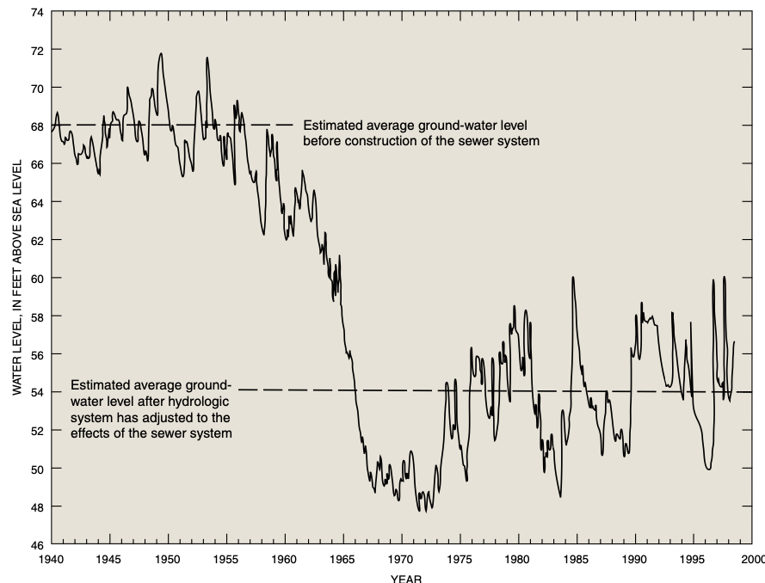

(<https://pubs.usgs.gov/circ/circ1186/pdf/circ/circ1186/pdf/circ1186.pdf>)

**Road runoff**

It is also misleading to suggest that sewers are going to radically prevent nitrates from flowing into our tributaries and streams. Rainwater contains nitrogen. The delivery of this nitrogen into the environment is known as “wet deposition.” According to Mark Romaine, an independent expert on Long Island’s water supply, nitrogen also falls naturally from the atmosphere on non-rainy days and this delivery is known as “dry deposition.” The total annual atmospheric deposition in Suffolk County is 2,500,000 pounds annually.

A significant contributor to the problem is the growth of impermeable surfaces such as parking lots. Nitrogen accumulates due to dry deposition, and during a rain event, it is washed off along with the nitrogen rich rain water to a storm sewer that typically directs it to a stream bed or embayment. The growth of impervious surfaces will only increase direct nitrogen loading to waterways. New sewering will have little to no effect on this process.

A report from Long Island Regional Planning Chair Lee Koppelman in 1978 stated that approximately 90% of the total coliform bacteria loadings to the Great South Bay is from stormwater runoff. Other experts have determined that rainstorms wash a variety of pollutants into the waterways with characteristics not unlike sanitary waste.

There are measures that can be taken to mitigate stormwater runoff, including creating more recharge basins, and properly maintaining those that already exist.

Recharge basins are unlined excavations in the glacial deposits; they range from about 10 to 20 feet in depth and from less than 1 to about 30 acres in area. In Nassau and Suffolk Counties there are more than 2,000 recharge basins. (<https://www.usgs.gov/centers/new-york-water-science-center/science/long-island-inflow-groundwater-system>)

Perhaps more resources can be targeted for these measures that would have a significant cleansing impact on our surface waters rather than having a majority of that money go towards sewers and Innovative/Alternative (I/A) systems that will not improve this aspect of water quality. Parenthetically, consideration must be given to the fact that these I/A systems often require electric power to operate. Thus, the obvious question to be considered is how residents would deal with the detrimental sanitary conditions that would come about after a power outage.

**The pros and cons of nitrogen and its impact on shellfish**

An important question to be studied is whether the drinking wells in Suffolk County within sewer districts are cleaner than those in other parts of the county that aren’t. We already know Suffolk’s water is generally rated no less clean than Nassau’s, despite having far less sewered area.

Moreover, one would naturally equate cleaner waterways with a healthier shellfish harvest in our bays. If sewers led to cleaner waterways, shouldn’t we see a more robust shellfish industry in sewered areas? One would think so. But the opposite is true.

Algae and clams both rely on nitrogen as a food source. In 1970, clams were abundant, and they contributed to the nitrogen cycle by excreting nitrogen, which in turn fed the algae. This cycle was sustained by a steady flow of groundwater.

Something very interesting appears when one observes the oyster harvesting in Nassau County. These harvests have diminished significantly throughout the county with one glaring exception. It’s in Oyster Bay itself. It so happens that these plentiful harvests are in an area where there are no sewers. Yes, that’s right. The homes and businesses in the area are still accommodated by cesspools.

It seems counterintuitive based upon the information that’s spewed out from the media that there would be greater harvest in areas where cesspools are plentiful as opposed to sewers.

The $6 billion dollar clamming industry experienced a 93% reduction in harvests in the past 25 years, according to the New York State Department of Environmental Conservation. (<https://cals.cornell.edu/news/restoring-long-islands-shellfish-population>)

The following charts illustrate how the shellfish harvest began to drop precipitously around the same time that sewers were coming onto the scene on Long Island. While other factors could have contributed to these statistics, it is hard to ignore the inverse relationship between the numbers related to shellfish harvesting and the expansion of sewers.

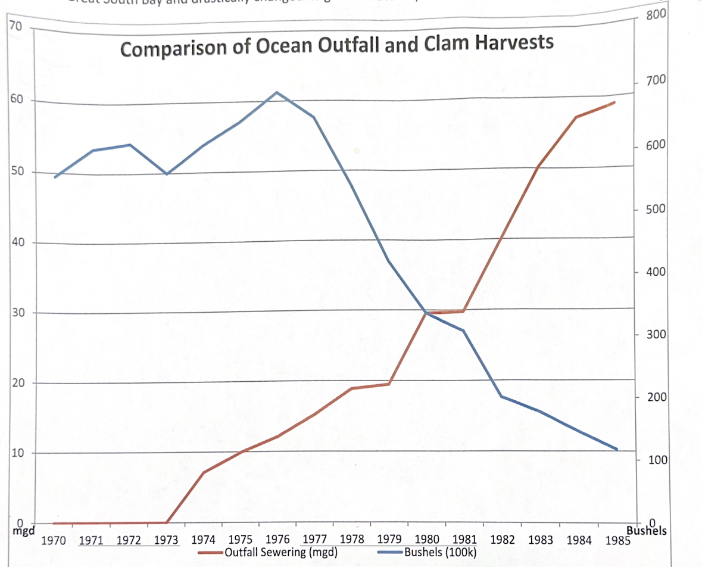

Clam Harvest Data - "The Great South Bay" SUNY Press page 67 Ocean Outfall Data - BASE FLOW OF 10 SOUTH-SHORE STREAMS, LONG ISLAND, NEW YORK, 1976-85, AND THE EFFECTS OF URBANIZATION ON BASE FLOW AND FLOW DURATION USGS 1992

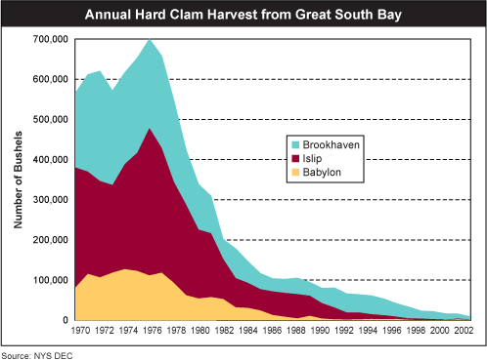

Interestingly, while too much nitrogen is problematic, a certain level of nitrogen is needed for shellfish to thrive. Where there is no nitrogen, there is limited shellfish. Where there’s too much nitrogen, massive algae blooms form. There is a balance that must be struck. The data suggests, however, that shellfish flourish to a greater extent where sewers are NOT present.

**Maintaining water flow equilibrium**

The ability to maintain a healthy equilibrium in the bay may also be negatively impacted with sewers. An example can be referenced by observing how the Great South Bay reacted after a breach on Fire Island near Bellport, Suffolk County after Superstorm Sandy in 2012. The breach led to a noticeable cleansing. This created a mistaken belief that new inlets were needed. If inlets were the sole cause of improvement, the question is, why don’t these improved conditions exist in the vicinities of Fire Island or Jones Inlets? The reason is that these two inlets are in sewered areas, while the new breach occurred in an unsewered area where there was enough groundwater to reestablish the necessary balance of freshwater outflow and tidal interchange.

It should be noted that the Town of Babylon has seeded over 42 million clams and 10 million oysters without resurrecting their shellfish. This is despite being near the largest "breach" in the Great Sound Bay, the Fire Island Inlet.

Studies in the vicinity of Bellport Bay's breach and spawner sanctuaries in Shinnecock Bay (both unsewered) indicate that the recharge provided by cesspools and septic systems maintain a stable water table that allows for the resurgence of shellfish.

More importantly, in 1970 all of Long Island east of Meadowbrook Pkwy. was unsewered and the bay supported a catch of over 500,000 bushels annually.

**So why is there this big push for sewers?**

Part of the big push for sewers relates to the fact that sewers give a license to developers to no longer need to set aside land for traditional sumps that would allow runoff to accumulate and then be filtered before flowing back into the aquifer. Developers also wish to pass muster with zoning boards, which are very restrictive in non-sewered areas.

Sewers can be very helpful in sparking economic development. This is especially true in downtown corridors. These locations thrive when there is greater density of housing and more restaurants and bars for the apartment dwellers to frequent.

We believe that the construction of new sewers in certain designated areas and Suffolk County certainly does make sense. On the other hand, it would be a colossal waste of money to sewer over the majority of Suffolk County just for the sake of creating sewers. Some will say why not spend $6 billion on sewers if you’re collecting the money anyway. Well, the answer is that that money can go back into the pockets of our taxpayers or could be used for other pressing needs. Just spending more money on sewers will not, as some advocates claim, give you cleaner water. In fact, in some cases, it could make the quality of the groundwater worse.

Consequently, there is more study and analysis required to determine why, and where, more sewers should be constructed. As previously noted, there is a significant advantage to allowing for sewers where we want enhanced density. That would be in our downtown corridors near transportation outlets. We want more bars and restaurants there. We want more workforce housing there. And space is at a premium.

There may be a need for sewers in areas with very high water tables, such as Oakdale and Mastic/Shirley where the natural filtering down cleansing process from the cesspool can’t apply.

**Beware the Environmental/Construction Industrial Complex**

President Eisenhower warned us of the Military/Industrial Complex. It was, and is, a tremendous cottage industry that makes a great deal of money pushing out more weaponry, whether needed or not. Make no mistake there is a cottage industry involved in this quest to sewer over Suffolk County.

It is headed by engineers, attorneys, contractors and unions that stand to benefit from this massive public works project.

And don’t forget the incentive for Suffolk’s municipal unions to seek a higher sales tax and an extension of the present sales tax program so that the $700 million in surplus monies that came into the county after the pandemic is not spent on sewers or the environment, but rather for more departments, employees, salaries and government programs.

**Using FEAR to sell the program**

One of the most obvious, and successful tactics employed by these advocates is good old fashioned FEAR. Pass this referendum, give us billions of dollars to invest for you at our discretion and we will save you.

Much of this debate is eerily similar to what we’ve experienced with the debate of climate change. There were those on one side who foolishly deny that the climate is changing. They further deny that human activity has anything to do with it and suggest this is just part of a natural cycle.

We believe they’re wrong.

On the other end of the spectrum are those who continue to scare Americans that they’re going to die in 12 years unless the public hands over tens of trillions of dollars to their government, along with unlimited authority for those in power to impose draconian measures.

It’s the same type of tactic that was used with COVID funding and limiting free expression. Get in line. Don’t challenge what we in government say or you will die from the virus. Moreover, we will deplatform you, get you fired or canceled while labeling you a murderer.

We now have learned about the major mistakes that were made by suppressing important information - including information that came out showing that closing schools was a terrible idea.

Oops, too late. Those in power already got their trillions of dollars and were able to impose their mandates on us.

As to climate change, there should be an admission that it is real and is problematic, and it must be addressed. But the answer is not imposing supposed remedies that would cripple the US economy and throw billions of people around the world back into poverty, while doing little to actually stem carbon output. This is in large part because debilitating, economy stifling measures are being imposed only on the western democracies, especially US citizens, while China continues to build a new coal plant every week.

The answer lies in American innovation that will create the new products that will make the creation of electricity more economically viable for nations around the world when producing cleaner energy. Just wishing and hoping that solar and wind will do the trick is a fantasy.

It’s quite reminiscent of how State leaders pushed offshore windmills onto the scene. There was article after article and press release after press release by virtue signaling newspapers and politicians claiming how windmills will save the day. When asked how much they would cost and what the actual benefit is, our leaders became mum. In fact, in a startling Newsday article this past summer when a state environmental leader was asked what the cost of a new windmill project would be, she said she didn’t know and deferred the reporters to the private company that was making the investment. When the company was contacted, their spokesperson said that they were not at liberty to disclose that number. <https://paper.newsday.com/html5/reader/production/default.aspx?edid=38fa9b54-1545-44f8-bb5f-8e81ca56f167&pnum=8>

And now we see reports that there will be a $1,600 increase in the next three years paid by utility customers. It shouldn’t be a surprise. They did a bait and switch on the Long Island public. They told you you were going to die unless you approved these wonderful programs but held back their actual cost. Once the money came flowing in, they still refused to provide the cost. It’s only when residents saw their astronomical rate increase that they found out how much they’re being screwed. Taxpayers should be leery of letting this happen again.

We see those similar fear tactics being employed in the sewer debate.

The questions as to where and why we should expand sewers must be vigorously discussed **before** we rush into remarkably expensive proposals that may do little to achieve our goals of achieving cleaner water. Our officials should weigh out the cost-benefit analysis of having to pay $20-30,000 for an upgraded cesspool compared to the actual impact it will have on our environment. They should lay out the cost of what the construction of tertiary treatment plants are as opposed to allowing for the hook up of existing sewer plants that dump groundwater into the ocean. Perhaps just bringing existing cesspools up to code would be more realistic and economical than mandating tens of thousands of dollars for a septic system for a family owning a quarter acre plot.

Let’s get all those numbers together, do a comparison and then decide how much sewering we want, how many new tertiary plants we prefer and how many super size cesspools we think are worth it.

Get that info in hand before we ask for billions of dollars in more revenue from our residents. Remember, in 1986, it was touted that by increasing the sales tax by a quarter of a penny, we would preserve our groundwater forever. Well, $3 billion has been spent on that venture and now we’re being told, “Oops we have to do it all over again.”

Let’s be smart about this and do it the right way. And most importantly, let’s be honest with the people of Suffolk County regarding the cost and need of sewering and whether they help or hurt the environment.

**Extending the current quarter cent sales tax program another thirty years**

Suffolk residents must be aware that the county snuck in a provision in their proposal that will extend the present quarter penny sales tax for another 30 years. This is despite the fact that this present program does not expire for another six years.

Why would they be so anxious to extend it now? Perhaps because they can fold it into the sewer proposal that is preaching clean water. When stated that simply, it’s bound to garner lavish praise. But the 1/8th of a cent increase for more sewers is very much different from the extension of the present quarter penny sales tax that was first enacted in 1986.

As seen in the chart below, that program was divided into three subsets.

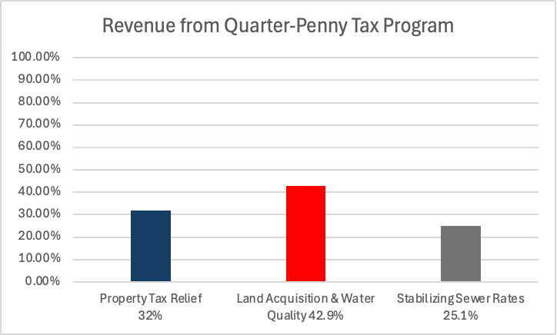

One provided property tax tax relief. Another collected monies to stabilize sewer rates so that no person in the sewer district does not have his or her rates exceeding a small percentage each year. The final subset is available to purchase open space and promote other environmental purposes.

The latter was sold as a measure that would forever protect our groundwater. It was a marvelous program that did preserve tens of thousands of acres throughout the county. It was a winner because it preserved open space for aesthetic reasons and also preserved the rustic atmosphere of our east end, which is a major tourist destination and revenue raiser.

But times have changed since 1986. All of the low hanging fruit available for land preservation is gone. There are very few open space parcels still remaining that are ripe for purchase. One can see the startling decline of acreage preserved in the last 12 years. So the question must be asked: Why are we continuing to fund this subset over $48 million annually for open space when perhaps that money could be better suited for other things such as sewers or improving cesspool productivity?

These are debates that should have happened, but never did. The attitude is, get the massive amount of money in hand first, and then we will concern ourselves with how to spend it.

That’s totally backwards. Before we commit taxpayers to give up billions of dollars of their hard earned income to the county, they have a right to know how and why it is being spent. The county government erred by not asking those questions and having them thoroughly answered.

Part of the reason for the blind allegiance to the sales tax increase relates to virtue signaling. The press has made it sound that this eighth of a cent tax increase is essential to save our island. Legislators do not want to earn the wrath of the unions or the environmental groups who give money and endorsements come election time. As noted above, those special interest groups have special reasons for wanting this tax increase.

**There’s ample money available for sewers without increasing taxes**

**Why tax the people of Suffolk again?**

The people of Suffolk County have already agreed graciously to tax themselves repeatedly for environmental protection, including an extra quarter penny sales tax increase already on the books since 1986 to provide open space purchases, stabilization of sewer rates, and cleaning of waterways.

Suffolk residents have been taxed, through the county and its 10 towns, $3 billion since the inception of this program to preserve our environment. (<https://libn.com/2016/10/13/spaced-out/>)

Presently, there is a plethora of funds available to allow expansion of our sewer districts without gouging the taxpayers further. For starters, the county was the fortunate recipient of over $580 million in free money from the federal government after the pandemic (not to mention the hundreds of millions of extra dollars unexpectedly flowing in due to huge sales tax revenues that accompanied inflated spending spurred by federal policies). These funds are so liberally allocated that even supporting sewer construction is permissible, as evidenced by the $10 million infusion of federal funds for sewer expansion in Patchogue and millions more for the Forge River in Yaphank. <https://www.nlc.org/article/2021/06/01/using-american-rescue-plan-act-funds-for-water-wastewater-and-stormwater-infrastructure-projects/>

Still more money is available that came from superstorm Sandy in 2012.

Wisely, some of those funds are being slanted toward mitigating the nitrogen issue.

And, as stated above, a total of $113 million flows into the county each year via the present quarter penny program.

Thirty two percent, or $36.4 million, is allocated towards property tax relief and should not be disturbed.

There’s also an additional $46 million in the sewer stabilization fund balance which could be used for more sewer construction, since the amount flowing into the fund each year is larger than what is needed to keep rates from increasing more than 3% annually.

Another $48.5 million annually accumulates for land acquisition and water quality programs.

Why not use that funding for sewer expansion? That’s half a billion dollars over the next decade.

Now that most of the prime sensitive parcels have been preserved, the pace of preservation has dramatically slowed down with only 540 acres preserved over the 5-year period of 2017-2021, averaging $8 million per year. Yet, we receive tens of millions of dollars a year into the acquisition fund. Consideration could even be given to splitting those revenues for sewers and open space, especially in the neglected West End.

If Suffolk didn’t have all this extra money available it would be a tough call as to whether we’d have to entertain an even higher sales tax to construct sewers. But when the blindfold is peeled off and residents see how much money is already available for sewer construction, it would constitute malpractice to saddle our already over beleaguered taxpayers with yet another unnecessary tax increase.

Most importantly, why is there an attempt to extend this massive program another thirty years when it’s not even slated to expire until 2030? If we were going to extend it, shouldn’t there be a vibrant debate about the details?

*******

**Acknowledgements**

Special thanks to the contributing collaboration of Mr. Mark Romaine (no relation to the Suffolk County Executive), who has accumulated significant expertise on the topic of sewering on Long Island.